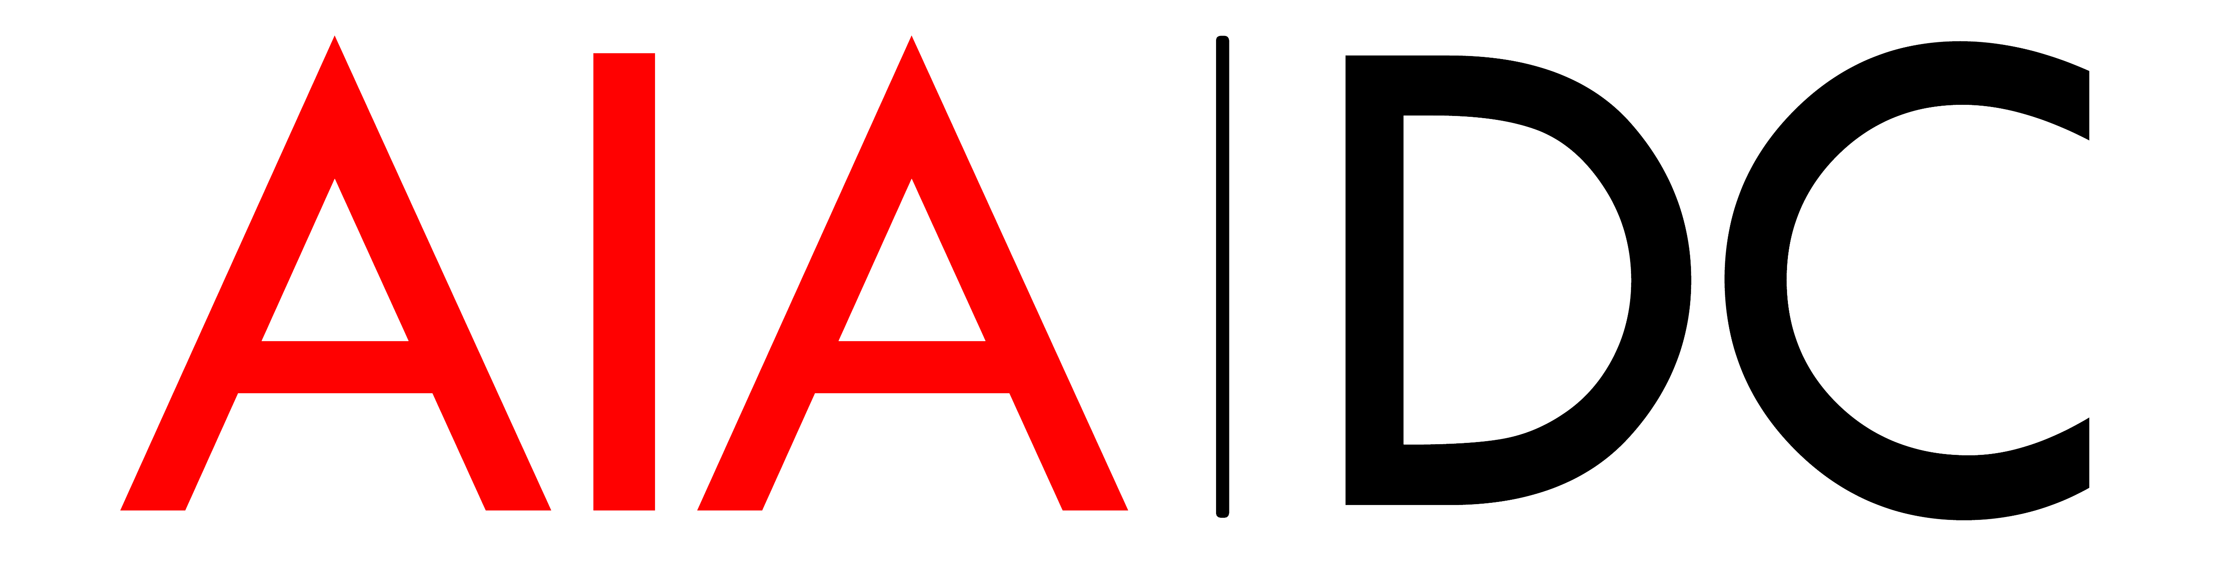

Thank you so much for your interest in being a part of the 2021 AIA|DC Board of Directors. Below are three questions that we asking each applicant. Please feel free to add additional space or pages for your answers if you need to. Kindly return this to mfitch@aiadc.com with a recent resume by Tuesday September 1, 2020 for consideration.
1. Why do you want to join the Board? Please be specific about your interests.

2. What kind of experience do you have being on a board or in other nonprofit organizations?

3. Can you meet all the expectations of Board membership—including:
a. Attend at least 8 Board Meetings (in person or virtual)
b. Work as a committee liaison
c. Represent the Board to outside organizations
d. Serve as ambassadors to the community
e. Recruit 2 AIA|DC Corporate Affiliate Members
f. Attend events, and encourage others to attend events
g. Act as a resource for the Executive Director
h. Give a personal gift to WAF of at least $250.
i. Raise sponsorship of at least $2500.

If you believe you can meet the expectations described above please indicate your agreement to do so by signing and dating here. Unsigned questionnaires will not be presented to the nominating committee.

I agree to meet all the expectations described above.

Signature / Date

