Create Your Own Collage!
Saturday, April 6, 2024 | 1:30–3pm
District Architecture Center

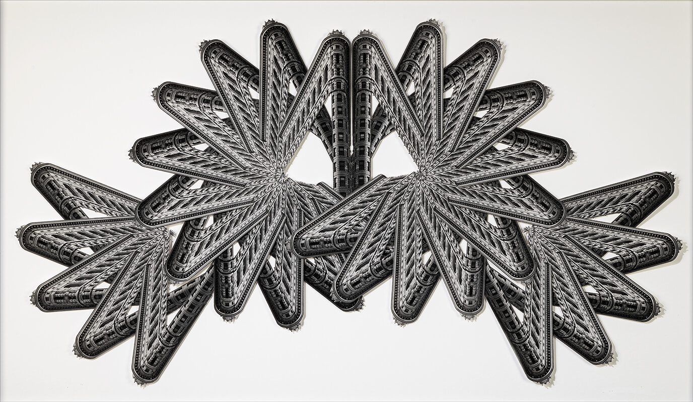

Meet Adrienne Moumin—photographer, collage artist, and educator. Adrienne creates intricate collages with photographs of simple structures. Follow Adrienne on a fun-filled journey through her collage-making world. Then, pick a photo of a building in DC and make it into a collage with your own artistic style! Art supplies, including small frames, are provided by the Washington Architectural Foundation.

This program is intended for ages 8 to 12. Attendance is limited to 12 children.

Price
$20 for Non-Member Kids
$15 for AIA, Assoc. AIA, & DAC Member Kids
$10/child for Groups (more than one child)
Registration required—no walk-ins.
Register here or visit www.aiadc.com

