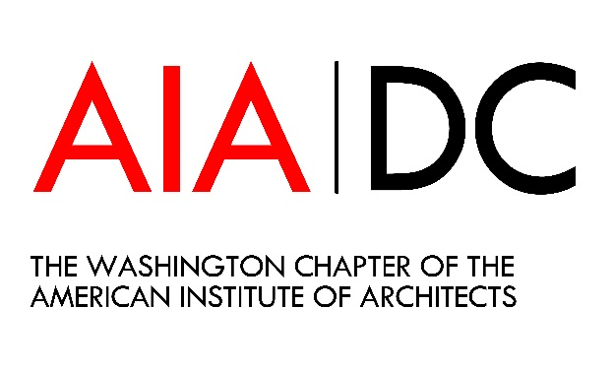
Sponsorship Request Form
Name:
Title:
Company/Organization:
Address:
City, State, Zip:
Telephone:
Email Address:

I/My company would like to sponsor the ___ _ Committee.
____ $2,000
____ $1,500
____ $1,000
____ $500
____ $250
____Other
____ This is a personal donation.
____ This donation is on behalf of a company/organization.

Payment Options
____I would like to pay by credit card or ACH (An invoice will be emailed to you when we receive your pledge)
____I would like to pay by check. Please make all checks payable to the Washington Architectural Foundation and mail to 421 7th Street, NW Washington DC 20004
The Washington Architectural Foundation is a 501(c)(3) charitable organization. Contributions are tax deductible in accordance with IRS regulations. Please email this response form to Ivan Jerome at ijerome@aiadc.com.

