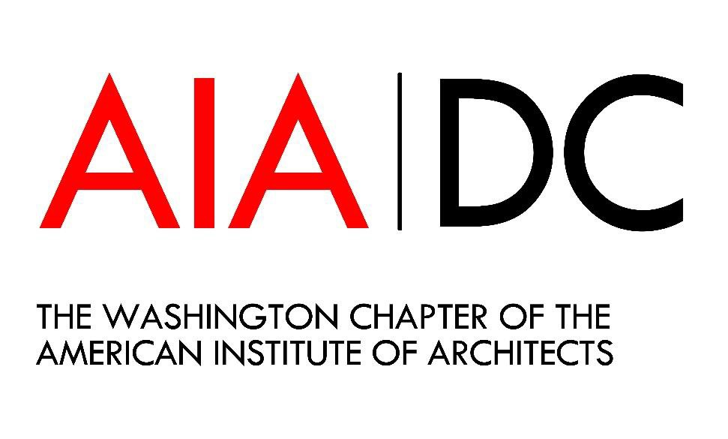
Committee Handbook

Contents
- Role of the Committees
- Role of AIA|DC Staff
- Committee Governance
- Committee Plans and Agreements
- Committee Events
- Committee Meetings
- Committee Finances
- Sponsorships
- Social Media and Communication
- Advocacy
- AIA|DC Staff Contact Information
- Forms and Templates
  - Committee Plan Template
  - Committee Agreement
  - Request for Reimbursement
  - Sample Sponsorship Request Form

Role of the Committees
Committee members are subject matter experts of AIA|DC.

Committees are responsible for:
  - Organizing/Planning Events
  - Using networks to promote events
  - Participating in advocacy with the Board of Directors

Role of AIA|DC Staff
Staff operates DAC and directs the advancement of architecture in DC.

AIA|DC staff is responsible for:
  - Presenting committees with paths to channel their expertise and energy
  - Posting events and advertising
  - Collecting registration fees and answering registration questions
  - Event set-up (if held at DAC)
  - Getting learning unit approval and reporting learning units
  - Tracking finances for committees

Committee Governance
Have a method to reach decisions.

  - Committees may create whatever governing body they wish. Some have offices such as treasurer, secretary, and chair and others only have a chair.
  - Committees cannot use the words, board, director, or president to describe their positions. This is to avoid confusion with the Chapter’s board and staff.
  - Committees may not enter into legal agreements as they aren’t legal entities on their own.
Please consult with AIA|DC staff if the need for a contract arises.
  - Committees must have at least ten active members.
  - Committees must have two AIA|DC members in their governing body.

Committee Plans and Agreements
Committee Plans and Agreements are due on December 1. Committees have the option to submit two bi-annual plans on December 1 and May 1.

  - Each committee is required to submit an annual or bi-annual Committee Plan detailing projects for the following six months or full calendar year. Plans must include a detailed budget and calendar of activities so the Board of Directors can review them and see how the committee fits into the Chapter message. You’ll be given comments on your committee plan around the start of the new year, and again in June if you submitted a bi-annual plan.

  - Please note that you will need to reach out to DAC staff to confirm program or committee meeting dates listed on your plan. We’ll do our best to book the event on your preferred date.

  - Committee Plan Template
You do not have to use the template, it’s only a guideline to help you get started.

  - Committee Agreement
This is the agreement that each committee signs at the beginning of the year

Committee Events

AIA|DC committees are essential for providing education to other members!

Fill out the Event Request Form a minimum of 4 weeks before your event.

  - We aim to have as many committee events at DAC as possible, however we won’t always have space available or be able to let you into the space before your booked time. DAC is in a prime location in downtown DC which is great for engaging people in architecture, but is expensive to run. We often rent the space to outside organizations to supplement income from AIA|DC and WAF activities. These rentals are essential to keeping the doors open so we sometimes have to make adjustments to our plans to accommodate them. In-person committee events at DAC will be held on Mondays. Availability is contingent on staff and whether another event is already booked.

  - Please fill out the Event Request Form no later than four weeks from the date of the program you are holding. To ensure a good turnout for your events, we need this time to get CEUs approved and advertising the event. The form can be found at www.aiadc.com/page/aiadc-member-resources. Reach out to the Operations Coordinator or education@aiadc.com to inquire about open dates before confirming speakers.
Photos really help with advertising! Please make sure they are horizontal and do not have any text.

  - After the form has been submitted, staff will get approval of learning units from AIA National and post to the website along with a registration link. The person who submitted the form will be notified when the event is posted so the committee can start spreading the word in its network. Registration fees are collected by the Chapter and will show on your

next quarterly financial report.

  - If your program is at DAC, please let staff know your AV needs in advance so we can have everything ready when you arrive. We have microphones, projectors, built-in screens.

  - If your program is virtual and has credits attached, you must use our Zoom account to host. Zoom can only record attendance through the webinar feature, which the chapter pays for. We insist that events are hosted in our Zoom account so that we can ensure attendees get credit for attending.

Event sign-in is an important step, because the sign-in sheet is the official record of attendance for AIA learning units.

    - Learning units must be submitted within two weeks of the course. Please send the sign-in sheets from off-site events to staff as soon as possible. Members appreciate seeing their credits quickly, so we aim to get them submitted within two days.
    - Registrants must attend the entire session to get credits. Anybody arriving more than 15 minutes late to a presentation can’t receive credit for it.
    - If the attendee doesn’t have their AIA number with them, we can pull their account up by name. But we can only find them if their name is written legibly! AIA numbers are always preferred to ensure credit will be received.

  - Do not advertise events before staff has created a Cvent link and calendar listing! When an event is announced it is important to have everything in place so that people can register right away. If someone wants to register but can’t, they are not likely to come back and try again. Rather than boosting registration, this can lower registration.

  - AIA|DC staff needs to know about all events that committees are participating in, even if it doesn’t require any staff action. We often get questions about committee events, so in order to be helpful we need to know about them in advance. Don’t forget that we may be able to advertise it as well!

  - AIA|DC staff can only manage AIA credits. If you’d like to offer other credits for a course, reach out to the administering organization.

  - Events need to be open to non-members and members. An essential part of the service we provide is access to continuing education classes, so we need to maintain the same level of service for all our members and to the rest of the AEC community. In the case that the event will fill up quickly, we can give the committee some time to sign up first before posting the event publicly.

Committee Meetings
Don’t forget to schedule your committee meetings!

  - To schedule committee meetings, contact the Operations Coordinator. Please let us know about committee meetings even if they are not being held at DAC so they can be posted to the website calendar. If you wish to have your meeting virtually, you may host it in our Zoom account or on another account. We have one account for meetings that will be assigned on a first come, first served basis.

  - Committees are encouraged to schedule all their meetings at the beginning of the year to improve attendance. It’s easier for new members to get involved if they know when and where you’ll be meeting in advance.

Committee Finances
Committees can use funds to support their educational programs.

Don’t forget to submit your receipts for reimbursement!

  - Committee funds are housed in the AIA|DC bank account. Committees can use 80% of their income for educational purposes. The other 20% goes into the Chapter’s education budget to help cover costs for other programs such as DAC Design lectures.

  - We know that starting the year without funds can be a challenge, so each committee receives $350 from the Chapter at the beginning of the year to help jump start their activities. In order to receive the funds, the committee must be represented by
at least one member at the Annual Meeting, Committee Education Bootcamp, and Committee Bootcamp.

  - Committee Chairs will receive a report at the end of each quarter with year-to-date financial information. We will do our best to provide information on request, but not all information will be instantly available.

  - Because the Foundation’s mission is education, any spending of sponsorship money must have an educational component. Any committee doing a networking/social event needs to include a short presentation (at least 15 minutes) pertaining to the activities of the committee or some aspect of architecture or the profession. It doesn’t need to qualify for AIA learning units.

  - If you are unsure if a purchase will qualify, contact AIA|DC. Please note that you cannot donate to outside organizations because supporting another cause is speaking on behalf of the Chapter. Only the board can speak for the organization.

  - Committees access funds through reimbursement from the Chapter. To request a reimbursement, submit the name, address, and receipts. An optional reimbursement form is attached and can be found on the website. A check will be issued as soon as possible provided the event has already been completed.

  - Committee funds do not roll over into subsequent years because the Chapter operates on a cash basis.

  - Committees may fundraise for outside organizations if they are partnering with them on a project, but the committee must do a similar fundraising effort for the Washington Architectural Foundation. Partnering with outside organizations is valuable, we just have to ensure our donors don’t forget about giving to WAF.

Sponsorships
As professionals in the AEC industry, you have cultivated networks that are a great source of sponsorships. Go out there and fundraise!

  - Ask the Executive Director before approaching any sponsors. This policy is in place so multiple committees don’t ask for funds from the same sponsor at the same time. The left hand needs to know what the right hand is doing!

  - Sponsorships go through the Washington Architectural Foundation and are transferred to the Chapter for committee use.

  - If a committee has a Sponsoring Affiliate, $2000 goes to committee activities and $500 goes to the Chapter education budget. For more information on Sponsoring Affiliates, see the membership page on aiadc.com.

  - A sample sponsorship form is attached. You’re welcome to use it as a guideline to get started.

  - If committees would like to offer sponsorship benefits that would need to be organized by the Chapter, such as Newsletter recognition or event tickets, please get staff approval first.

  - If your sponsor requests an invoice, please contact staff to create one.

Social Media and Communication
Committees can write blog posts for aiadc.com!

Don’t forget to snap some photos!

  - Committees are welcome to create their own social media accounts. Accounts must contain
“AIA|DC” or “DC” to avoid confusion with other Chapter’s committees.

  - Committee events are included in Newsflash for the two weeks prior to the event.

  - Committee events may be included in the Newsletter depending on space availability.

  - If a committee would like to advertise an event on the AIA|DC social media, two tweets are allowed per event. The committee must provide the language to be posted to the Communications Manager.

  - Committees are encouraged to write blog posts for aiadc.com. Blog posts are a minimum of 300 and a maximum of 1000 words with at least one photograph. Contact the Communications Manager with content. It’s best to submit the blog at least two weeks before the suggested post date.

  - One of the staff’s roles is to assist committees with creating communications for publication. Anything created for publication using the names or logos for AIA|DC, AIA National, DAC, or Washington Architectural Foundation must be created in concert with staff.

  - Committee logos must be approved by the Executive Director to ensure they are cohesive with the AIA|DC image.

  - Committees can create email addresses using whatever service they would like. If committees would like to use the aiadc.com domain, contact AIA|DC.

  - Send us a photo! We can include a photo of your committee on your meeting listings.

Advocacy
Contact your board liaison!

  - Committees are encouraged to be involved in the advocacy of the Chapter. The Board manages all the advocacy communications of the Chapter in order to create unified positions. Please contact your Board liaison to get involved.

AIA|DC Staff Contact Information
Mary Fitch, AICP, Hon. AIA Executive Director mfitch@aiadc.com
Scott Clowney, Assoc. AIA Director of Exhibitions & Public Programs sclowney@aiadc.com
Lily Oberst
Operations Coordinator
loberst@aiadc.com
Katie Spencer
Director, Professional Education kspencer@aiadc.com 202.347.9403 x 2004

Washington Chapter of the American Institute of Architects

