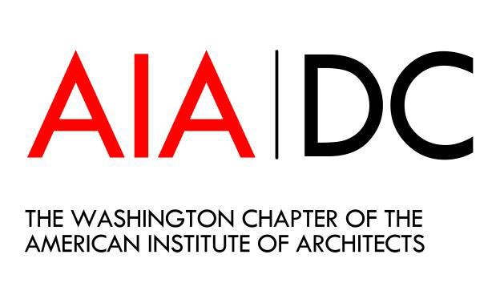
Committee Name
2023 Committee Plan

Organization and Leadership
  - Chairpersons:
  - Secretary:
  - Treasurer:
  - Communications:
  - AIA Liaison:

Committee Roster:
Committee Member | Phone | Email

2022 Mission & Initiatives
  - Maintain relationships and communications with key sponsors.
  - Etc.
  - Etc.
  - Etc.

2022 Budget

Revenue | Registration Income | Sponsorship Income | Total  Income | Total for Committee (80%) | Total for Chapter Education (20%)
Committee Stipend |  | $350 | $350 | $350*
Event Name
Event Name
Event Name
Event Name
TOTAL
Expenses (examples) | Amount | Total
Event Name - Catering
Event Name - Venue
TOTAL
NET REVENUE
*100% of the Committee Stipend is retained by the committee

- Program Schedule – Max 1 per Quarter

Event Topic | Month | Time of Day | In-Person or Virtual

5. Committee Meeting Schedule
Example:
Day/time, i.e. 2nd Tuesday of the Month
Live or In-person. Note: use of DAC is contingent upon staff availability
If In-person: Location
If Virtual: Indicate if the Committee needs to use the Chapter’s Zoom account

