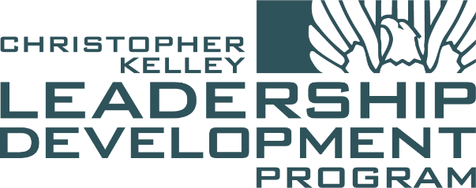

2022 CKLDP Application Packet
Date: 05 October 2021

Welcome
Thank you for your interest in the Christopher Kelly Leadership Development Program (CKLDP) and having the courage to make an investment in the development of your practice of architecture. The CKLDP was developed understanding that the transition from an employee to a leader is one of the most challenging + uncertain times in the architectural profession. The program offers scholars the opportunity to: surround themselves with like-minded emerging professionals; engage leaders in the profession - as well as learn for leaders outside the field of architecture; and most importantly assist you in designing your future.

CKLDP was founded in 2013 by the Emerging Architects Committee (EAC) of the AIA|DC Chapter. The program is in memory of Christopher Kelley, an employee of Gensler and an active member of the DC architectural community. Christopher was a recipient of the AIA Young Architects Award in 2010 and an exemplary, emerging young leader. Since its founding, the CKLDP has been established in several cities across the country and strives to carry forward Christopher’s legacy by actively training and nurturing the next generation of leaders within the architectural profession.

Taking place from January to September, the schedule consists of nine half-day sessions, with one session occurring per month for the duration of the course. Each session is planned + attended by a group of 16 emerging professionals, selected by our hand-picked jury, from across the DMV. The CKLDP curriculum focuses on core professional skills such as:

- firm management
- collaborative excellence
- negotiating skills
- client development
- community leadership
- trends analysis
- entrepreneurship
- the future of the practice
- leadership

Each year, a select number of scholars from the previous year are selected to help guide the next year’s class. This way, the program is continually evolving, allowing the scholars to learn on an ongoing basis about thoughts and ideas relevant to the architectural profession today.

The program’s success in addressing this need was acknowledged in 2018 at the AIA Grassroots Conference. The AIA|DC CKLDP was recognized with the AIA CACE Component Excellence Award for Knowledge Sharing Initiatives. By joining the CKLDP, you are becoming a part a core group of successful architects + leaders in the profession to help redefine the practice. Since the scholars are responsible for planning in each of the individual sessions, you help define the program’s success + continue its development for the future scholars.

Please note, this packet is not intended to serve as the application, so please do not submit this document. This packet was designed to assist potential applicants in the preparation of responses to the online application questions + short answers. The packet contains the following materials:

- application instructions
- session overviews
- online application questions + short essays
- application checklist

Please use this packet to help organize all your materials + take advantage of the checklist to ensure all application materials are properly prepared.

Speaking for all the past scholars, we wish you the best of luck in the application process + we look forward to welcoming this year’s scholars at the Bootcamp in January 2022. We personally hope each of the selected scholars get as much from the program as we did.

Table of Contents
Application Instructions 1
Overview 1
Schedule and Curriculum 1
Application Process 1
Tuition 2
Tuition Assistance 2
AIA Membership 2
Required Commitment to the Program 2
AIA Continuing Education 2
Honoring Christopher Kelley 2
Contact 2
Applying to CKLDP 3
Important Reminders 3
Required Supplemental Documents 3
Optional Supplemental Document 3
Required Short Answer Questions 3
2022 CKLDP Session Schedule 4
Session Summaries 4
January | Boot Camp (Attendance Required) 4
February | Session #1: Leading Together 4
March | Session #2: Entrepreneurship + Management (½ HSW) 4
April | Session #3: The Art of Negotiation (HSW) 4
May | Session #4: Research + Data (½ HSW) 4
June | Session #5: Business Development + Marketing 4
July | Session #6: Industry Game Changers (HSW) 4
August | Session #7: Community Engagement (HSW) 5
September | Session #8: The Future of Our Culture (½ HSW) (Attendance Required) 5
CVENT Online Application Questions + Short Essays 6
CVENT Questions 6
CVENT Short Essays 7
Application Checklist 8
2022 CKLDP Participation Agreement Form 9
2022 CKLDP Tuition Assistance Request Form 10

Application Instructions

Overview
In 2013, AIA|DC developed a unique training program to help cultivate the District’s next generation of design industry leaders. Now heading into its ninth year, the Christopher Kelley Leadership Development Program (CKLDP) is seeking a promising new cohort of motivated professionals to participate in the 2022 session. Prospective candidates must complete an online application demonstrating proven career success, community involvement, and leadership qualities. Professional recommendations shall be submitted as part of the application, and employer support for a candidate’s participation is also requested.

Schedule and Curriculum
The CKLDP schedule consists of nine half-day sessions, with one session occurring per month for nine months. Program participants include sixteen talented emerging professionals* that have been selected through a competitive application process. The CKLDP curriculum focuses on core professional skills such as firm management, collaborative excellence, negotiating skills, client development, community leadership, trends analysis, entrepreneurship, the future of the practice, and of course, leadership. The program is kicked off by an introductory “Boot Camp” session, where participants get to know each other, develop curriculum goals for the year, and learn about the session framework for the remainder of the program sessions. Program participants, dubbed scholars, then work in pairs to plan and execute the monthly sessions based on their expressed interests and expertise. Each pair of scholars is responsible for planning of one of the remaining eight program sessions.

Sessions are held monthly from January through September, generally on the first Friday of the month, from 12:00pm - 5:00pm. A group Happy Hour occurs after every session so scholars can discuss the day’s topics and share ideas. A full list of session topics and specific dates are described below in the schedule.

* An emerging professional is not required to be licensed but should be actively working towards licensure. If licensed, they are within ten years of their first registration.

Application Process
Individuals can be nominated by their firm or can nominate themselves. Program participants will be chosen on the basis of a letter of interest, written application, recommendations, and resume. The sixteen selected applicants will represent a diverse group of emerging professionals that demonstrate strong potential as future leaders. Within their letters of interest, candidates should emphasize any previous leadership experiences, explain the unique qualities and expertise they would bring to the program, and clarify how they intend to utilize the skills learned from the program. A selection jury will convene to review applications in November.

- “Call for Applications” Announcement: October 12, 2021.
- “Applications 101” Information Session: An optional, informal Q&A session will be held via Zoom on October 19, 2021 at 6:30pm. This meeting will be hosted by the CKLDP Advisory Committee and provides potential program participants with an opportunity to ask questions and receive helpful hints about what to include, or not, in their program applications. Interested candidates are encouraged to attend, but attendance is not mandatory, nor does it influence the likelihood that a candidate would be accepted into the program.
- Application Submission Deadline: All application forms must be submitted by 11:59 pm on
Friday, November 19, 2021.
- Notification of Acceptance: Candidates will be notified if they have been selected by
Friday, December 10, 2021.
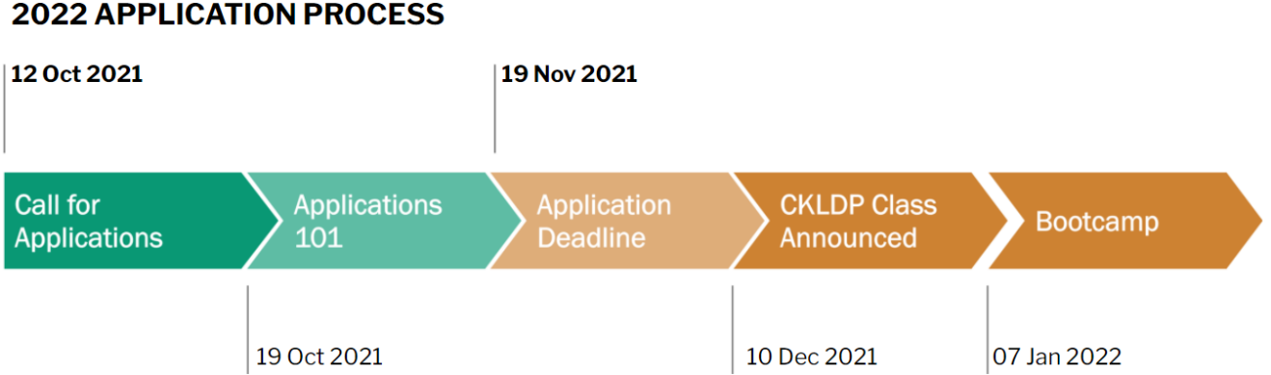

Tuition
Tuition for AIA|DC Members is $450. Tuition for non‐AIA|DC members is $550.

Tuition Assistance
Tuition assistance is available to individuals from small firms that have limited resources. The amount of tuition assistance granted will be at the discretion of the selection committee but shall not exceed 50% of the cost of tuition. The Tuition Assistance Request Form must be submitted with the program application.

AIA Membership
Though AIA membership is encouraged, it is not mandatory for program participation. Other allied organization members are also welcome to apply. Please note that preference may be given to AIA|DC members during the applications review process, but this is not always the case.

Required Commitment to the Program
The program’s success is directly related to attendance of the participants, and therefore attendance is mandatory. Each scholar will be required to sign an agreement affirming their commitment to attend, and the agreement must also be signed by a principal at the scholar’s firm. In the case of emergency, or provided due notice to the Program Chair, each scholar will be allowed one excused absence. If two sessions are missed, a fine of $50 will be charged. A further absence will result in an additional $50 fine and expulsion from the program. All scholars are required to attend the “Boot Camp” Session and the Closing Reception, no exceptions.

AIA Continuing Education
This program will offer AIA continuing education credits. A total of 45 CEU’s will be earned for full program participation (5 credits per session), 20-25 of which are intended to be HSW.

Honoring Christopher Kelley
Christopher Kelley, AIA was an active member of the architectural community, both in Washington, DC and beyond. He was a respected leader in the Institute and in Gensler’s DC office, and through his extensive volunteer efforts Chris contributed to initiatives that have had many positive impacts. In 2010, he was honored with the AIA Young Architects Award. As the jury stated in their commendation of his achievements, “Christopher has proven himself a young leader within and around the AIA, a real example for other young professionals.”

Contact
For more information please visit the CKLDP website (www.ckldp.com) or contact the 2022 CKLDP Executive Committee:

Role | Name | Email
Chair | Sarah Wahlgren Wingo | ckldp.dc@gmail.com
Past Chair | Daniel Blair, AIA, NCARB | ckldp.dc@gmail.com
Co-Founder | Sean Stadler, FAIA, LEED AP | sstadler@wdgarch.com
Co-Founder | Ryan McEnroe, AIA, ASLA, LEED AP | ryan.t.mcenroe@gmail.com

Applying to CKLDP
CKLDP applications can be accessed and submitted by clicking on the “Apply” button on AIA|DC’s website. This link can also be accessed on CKLDP’s website. Please note that at this time the online application form must be completed in one sitting; there is no ability to save a partial application and finish at a later time. Therefore, it is recommended that applicants have all their short answer responses and supplemental forms at hand and ready to upload before sitting down to submit.

Complete applications consist of the online form, responses to the three short answer questions (listed below for reference), and all required supplemental documents. Supplemental documents shall be uploaded in PDF format and named as indicated.

Important Reminders
- Eligible applicants should be classified as emerging professionals. Please note that emerging professionals are not required to be licensed but should be actively working towards licensure. If licensed, they are within ten years of their first registration.
- Applications and all supplemental documents must be submitted by
11:59pm on November 19, 2021 to be eligible for consideration.
- Incomplete applications may be rejected.
- Applicants must upload the following documents with their online applications.

Required Supplemental Documents
- Letter of Interest - Applicants must prepare a one-page letter of interest describing their reasons for applying to CKLDP, including how participation in the program will help them become better leaders, any previous leadership experiences, unique qualities that set them apart from their peers, and other relevant personal details. Letters of interest should help the selection committee get to know the applicant as an individual, beyond what can be discerned from their professional resume. Letters shall be uploaded in PDF format. (Last Name-First Name-Letter of Interest.pdf)
- Letters of Recommendation - Each application must include at least one, but no more than three, letters of recommendation. It is in the best interest of the applicant to ensure only strong letters of support that highlight an applicant’s leadership skills and/or potential are submitted. Recommenders do not have to be from within the architecture and design industry. Letters of recommendation are limited to one page each and shall be uploaded in PDF format. (Last Name-First Name-Letter of Recommendation-1.pdf)
- Personal Resume - Resumes shall include details of the applicant’s employment history, education, activities, volunteer experience, publications, and any honors or awards. Resumes are limited to two pages and shall be uploaded in PDF format. DO NOT submit a one-page generic firm resume with a list of projects only. (Last Name-First Name-Resume.pdf)
- Participation Agreement Form - Completed, signed, and uploaded in PDF format. (Last Name-First Name-Agreement.pdf)

Optional Supplemental Document
- Tuition Assistance Request Form - Tuition assistance is limited to AIA|DC members and is dependent on firm size (must be less than 10 employees). Candidates are encouraged to apply for tuition assistance only in cases of genuine financial need. (Last Name-First Name-Tuition Assist.pdf)

Required Short Answer Questions
Responses to the short answer questions are submitted as part of the online application form, not as a supplemental PDF. Please note responses are limited to 500 characters (not words).
- How do you define leadership, and how have you demonstrated leadership skills up to this point in your career?
- What are the three most significant issues/opportunities facing the profession today?
- What specific skills or knowledge do you hope to gain from your participation in the CKLDP?

2022 CKLDP Session Schedule

Session Summaries

January | Boot Camp (Attendance Required)
- Introduction to the course and fellow scholars
- Review of program templates
- Sponsorship + fundraising guidelines
- Session planning requirements + brainstorming activities
- Leadership introduction + guest speakers

February | Session #1: Leading Together
- The basics of leadership
- Understanding one’s personal leadership skills and how they relate to others
- Effective communication and emotional intelligence
- Optimizing team dynamics

March | Session #2: Entrepreneurship + Management (½ HSW)
- Office + firm management standards
- Firm organizational structures + long-term succession planning strategies
- Entrepreneurship opportunities within the practice
- Alternative business models

April | Session #3: The Art of Negotiation (HSW)
- Ethics + Law: from contracts and codes to professional ethics
- Overcoming negotiating pitfalls + behavior
- Advocating for oneself
- Public speaking + professional communication

May | Session #4: Research + Data (½ HSW)
- Thought leadership
- Creating the case for research in design + beyond
- Using data effectively
- Bridging the divide between architectural education + practice

June | Session #5: Business Development + Marketing
- Effective networking
- Using social media professionally
- Business development + pursuing work
- Building a personal brand

July | Session #6: Industry Game Changers (HSW)
- Sustainability + resilience in design
- The potential of historic reuse, preservation, and adaptation
- New tools to change how we practice (BIM, VR, etc.)
- Shaping the future of the design + project delivery methods

August | Session #7: Community Engagement (HSW)
- Understanding the needs of the community
- Tools to interact + collect data from the community
- Social responsibility of architects as community leaders and public servants; citizen architects
- Becoming more involved in one’s own community through philanthropic work + board involvement
- Impact through political advocacy

September | Session #8: The Future of Our Culture (½ HSW) (Attendance Required)
- Architecture’s role in culture, today + the future
- Embracing a diverse, inclusive + equitable world
- Becoming a mentor
- Growth through the CKLDP experience

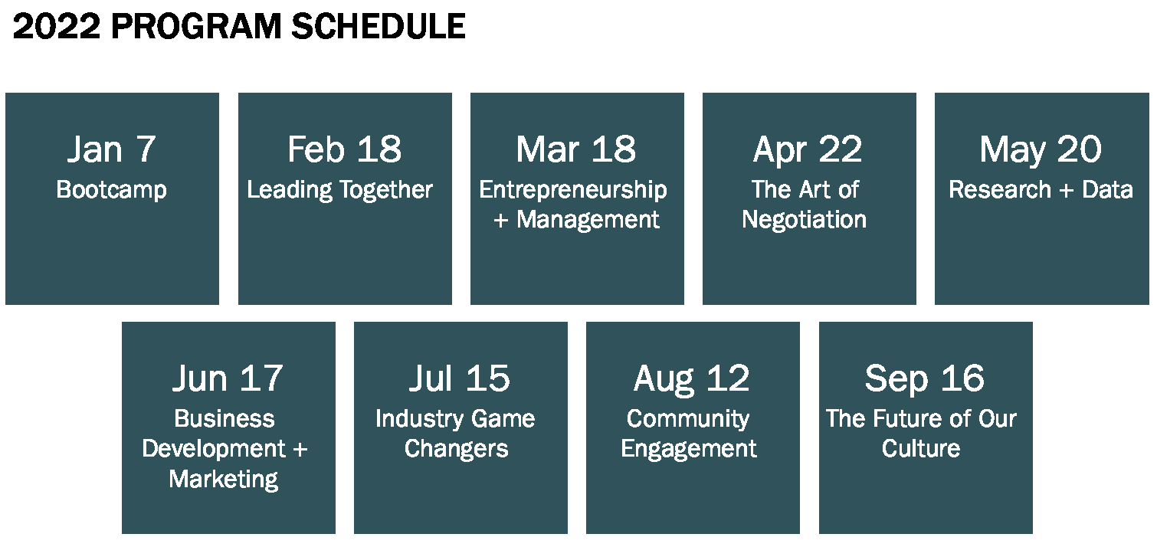

CVENT Online Application Questions + Short Essays

CVENT Questions
- Applicant Name:
- E-mail:
- Phone number:
- Date of birth:
- Gender:
- Ethnicity: | (Optional)
- Are you an architect or from an allied profession? Please specify.
- Are you an AIA member:
  - If yes, what is your AIA number:
- Are you a member of AIA|DC:
- Firm/Company Name:
- Firm/Company Size:
- Are you applying for tuition assistance? (If yes, please be sure to fill out the Tuition Assistance Application after you complete this form.)
- Please provide professional credentials (LEED AP, WELL AP, EDAC, CDT, PMP, etc.):
- From which accredited architecture program did you graduate:
- What year did you graduate:
- How many years of professional experience do you have:
- How many years since your first professional license:
- Letter of Interest Form:  (Last-First-Ltr of Interest.pdf) | Upload PDF
- Letter of Recommendation:  (Last-First-Ltr of Recommendation01.pdf) | Upload PDF
- Additional letter of Recommendation:  (Last-First-Ltr of Recommendation02.pdf) | Upload PDF
- Additional letter of Recommendation:  (Last-First-Ltr of Recommendation03.pdf) | Upload PDF
- Personal Resume:  (Last-First-Resume.pdf) | Upload PDF
- Agreement Form:  (Last-First-Agreement.pdf) | Upload PDF
- Tuition Assistance Form:  (Last-First-Tuition Assist Form.pdf) | Upload PDF
- Is the applicant an emerging professional? (Note: applicants are not required to be licensed, but actively working towards. If licensed, applicants shall be within ten years of first registration.)
- In light of COVID-19, the CKLDP executive committee is still weighing options regarding whether we can kick off the year in person or need to include a hybrid or virtual option. Please indicate your preference below to help us plan the best solution. Please note the answer to this question is not a determining factor for the scholar selection. | IN-PERSON MODEL: I am comfortable attending sessions in person if everyone will be required to wear masks, seating will be placed 6’ apart + CDC guidelines be followed.  GRADUAL TRANSITION MODEL: I would prefer to begin the year remotely, but would consider switching to an in-person option if numbers continue to improve and/or a vaccine becomes available.  VIRTUAL MODEL: I am not comfortable attending sessions in person and would only participate in the program if there is a remote or hybrid option.  HYBRID MODEL: I prefer that the program be designed this year to support a flexible/hybrid model. That all scholars be given the choice to opt-in to in-person (as feasible) or virtual participation throughout the year.

CVENT Short Essays
How do you define leadership, and how have you demonstrated leadership skills to this point in your career?
500 characters max

What are the three most significant issues/opportunities facing the profession today?
500 characters max

What are the specific skills or knowledge you hope to gain from your participation in the CKLDP?
500 characters max

Application Checklist
CVENT Short Essays | Essays drafted (recommend using spaces above to prepare the essays prior)  Each essay is less than 500 characters  Check for grammar + spelling errors
Letter of Interest Form | Check for grammar + spelling errors  File is named using format:  Last-First-Ltr of Interest.pdf  Upload PDF to CVENT application
Letter of Recommendation: | Reference contacted  Recommendation received  Check for grammar + spelling errors  File is named using format:  Last-First-Ltr of Recommendation01.pdf  Upload PDF to CVENT application
Additional Letter of Recommendation: | Reference contacted  Recommendations received  Check for grammar + spelling errors  File is named using format:  Last-First-Ltr of Recommendation02.pdf  Upload PDF to CVENT application
Additional Letter of Recommendation: | Reference contacted  Recommendations received  Check for grammar + spelling errors  File is named using format:  Last-First-Ltr of Recommendation03.pdf  Upload PDF to CVENT application
Personal Resume: | Resume updated  Check for grammar + spelling errors  File is named using format:  Last-First-Resume.pdf  Upload PDF to CVENT application
Agreement Form: | Complete agreement form  Check for grammar + spelling errors  Firm leader signature applied  Applicant signature applied  File is named using format:  Last-First-Agreement.pdf  Upload PDF to CVENT application
Tuition Assistance Form:  (not required – reserved for applicants at firms that have less than 10 employees) | Verify applicability  Complete form + short essay  Check for grammar + spelling errors  File is named using format:  Last Name-First Name-Tuition Assist.pdf  Upload PDF to CVENT application

2022 CKLDP Participation Agreement Form

Overview
CKLDP’s success is incumbent upon active participation by the program scholars, and therefore session attendance is mandatory. Each member is allowed one excused absence. If two sessions are missed, a fine of $50 will be charged. A second absence will result in an additional $50 fine and expulsion from the program.

The following agreement form must be completed and signed by the applicant, firm/company principal, and/or nominator. These additional signatures are required to demonstrate the firm’s commitment to the supporting the applicant’s full participation.

Applicant’s Signature
I fully understand the attendance and tuition requirements for the Christopher Kelley Leadership Development program and agree to fulfill those requirements if selected.

Signature |  | Date
Printed Name of Applicant |  | AIA Number (if applicable)

Firm Leadership Signature
I authorize and encourage the above applicant to participate fully in the Christopher Kelley Leadership
Development Program and fully understand the attendance requirements as outlined above.

Signature |  | Date
Printed Name of Applicant |  | AIA Number (if applicable)

2022 CKLDP Tuition Assistance Request Form

Overview
Tuition assistance is available to a select number of applicants. Grants may cover up to 50 percent of the program tuition and are awarded at the discretion of the AIA|DC Chapter.

Requirements to qualify for tuition assistance:
AIA|DC membership
Small firm size with limited resources
Legitimate financial need

If you believe that you qualify for tuition assistance, please complete the following and return with your CKLDP application.

Applicant’s Signature
I fully understand the attendance and tuition requirements for the Christopher Kelley Leadership Development program and agree to fulfill those requirements if selected.

Applicant Name
AIA|DC Member Id (if applicable)
Name of Firm + No. of Employees
Using the space provided below, briefly explain the reason you are requesting tuition assistance

