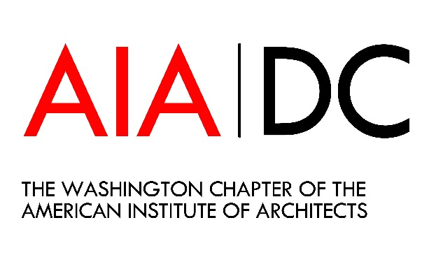
Sponsorship Request Form
Name:
Title:
Company/Organization:
Address:
City, State, Zip:
Telephone:
Email Address:

I/My company would like to sponsor the ___ _ Committee.
____ $2,000
____ $1,500
____ $1,000
____ $500
____ $250
____Other
____ This is a personal donation.
____ This donation is on behalf of a company/organization.

Payment Options
___ Check or money order (Made payable to Washington Architectural Foundation)
__ _ Credit Card # Expiration Date:
Name and Address for card billing if different from above:
Signature: ______________________________________________ Date: _________

The Washington Architectural Foundation is a 501(c)(3) charitable organization. Contributions are tax deductible in accordance with IRS regulations. Please email this response form to Sinclaire Erdwien at serdwien@aiadc.com.

