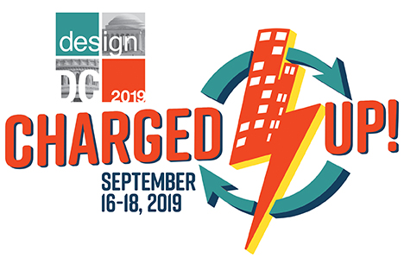
DesignDC Post-Conference Report
Be sure to follow-up with your supervisor by reporting on your DesignDC experience. The following checklist presents suggestions to be included in the report.

DesignDC 2019 Post-Conference Report

- Attendee Name
- Attendee Title
- Department
- Event Summary: DesignDC brings all segments of the building and design industry together for two days of face-to-face interaction, product review, education, and networking.
- Event URL: aiadc.com/DesignDC2019

Goals Met
Identify specifically what was brought back to the organization relevant to your business goals as payback for show investment.
- 1.
- 2.
- 3.

Cost Summary
- Registration Fee $
- Airfare $
- Transportation $
- Hotel $
- Meals $
- Total $

Conference ROI
Complete the following information for each of the education classes you attended.
- Session Title
- Session Presenter
- Session Summary
- Major Takeaways
- Action Items Identified
- Estimated Impact
Networking ROI
Please reference the notes you took onsite for your networking opportunities.
- Met With
- Discussion Focus
- Discussion Summary
- Major Takeaways
- Action Items Identified
- Estimated Impact

Business Relationships
Include contact information for all presenters, customers, exhibitors and attendees that would be useful for your company to contact post-event to address your business priorities.
- Name
- Contact Details
- Description

Exhibitor ROI
List exhibitor/solutions that you researched onsite for post event follow-up that align with business priorities.
- Exhibitor Name
- Solution of Interest
- Name Contact Details
- Description

Summary
Outline additional details on the ROI value to you and your company. In your summary, we suggest offering to train others on what you learned and include the date/time of your planned briefing in the space below.

