Architects Read-Activity
If You Lived Here: Houses of the World by Giles Laroche

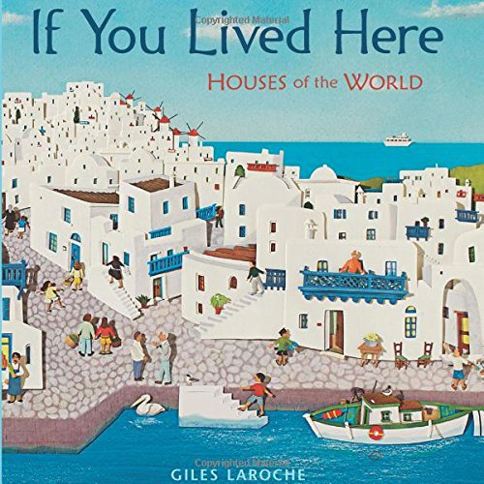

Now it is your turn to draw your home. Think about what makes your home unique. Is your door a bright color? Is your home tall or short? What kind of roof do you have?

Take a sheet of paper and draw your home with anything you want, you can use pencils, pens, markers maybe even paint.

Make sure to tag us on our social media @DistrictArchCenter

